DOUBLE JEAPORDY IN THE CITY OF CHICAGO

Chicago is unique as a jurisdiction that charges residents an annual fee for possessing a vehicle within the city limits, a so-called annual “wheel tax” of $200. Compliance is noted through the display of a city sticker on the vehicle. As ProPublica revealed, there are great inequities in the City’s enforcement of these city stickers, with a high concentration issued in low-income, minority majority zip codes.

Like every state nationwide, the Illinois state government issues license plates to all vehicles as approved registration, with an initial registration fee of $196 and renewal fee of $101. Therefore, to lawfully maintain a car in Chicago, double permission is needed, and the poor are being unfairly targeted. In 2017, the city of Chicago—through the Chicago Police Department and the Department of Finance—issued more tickets for “expired plates or temporary registration” than any other violation. In fact, 47,108 vehicles were ticketed for delinquent registrations with both the state of Illinois and the city of Chicago, demonstrating that nearly a quarter of all vehicles in Chicago that were ticketed for expired tags were also in state of double jeopardy.

**2017 VEHICLE REGISTRATION VIOLATIONS**

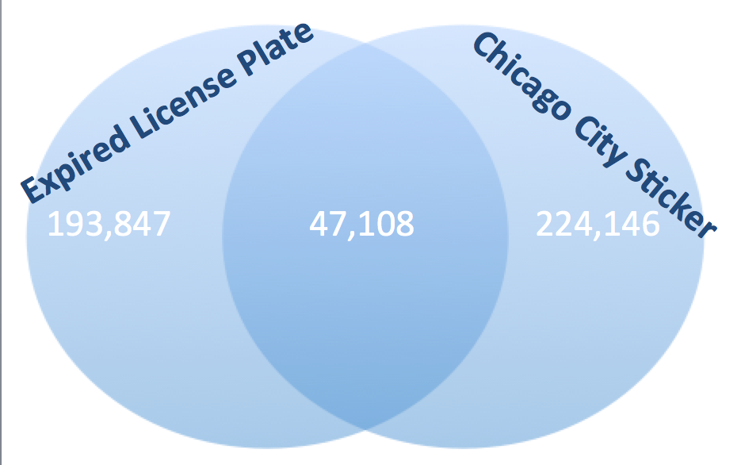

Unsurprisingly, the 5 neighborhoods with the highest concentration of “double violators “ were all located in the Southside neighborhoods of Roseland/Pullman, Auburn Gresham, West Lawn, Chatam and Calumet Heights, respectively. Abandoned vehicles only account for 10% of the double-violation vehicles and therefore are not driving the large prevalence of double violation.

To legally possess a vehicle in Chicago, an individual is expected to pay more than $300 on a regular basis to maintain compliance. This expectation is cost prohibitive in neighborhoods where average household income hovers around $35,000. Furthermore, these residents in neighborhoods with a high concentration of double violators rely on their vehicles for transport to jobs; failure to actively register with the City results in double fines. Therefore, this double jeopardy is an egregious inequity that

-----------------------END PARAGRAPH; BELOW IS RANDOM NOTES-----------------

If you’re able to get a map that highlights these zipcodes on a map, that would be a cool addition

Doubles: 60628 (Roseland/Pullman), 60620 (Auburn Gresham), 60629 (West Lawn), 60619 (Chatham), 60617 (Calumet Heights).

Enforcement of   targeting predominately low income minority neighborhoods.  The Department of Finance and the Chicago Police Department are the most frequent issuers of parking tickets overall, yet for both departments expired license plates were by far the most frequently issued tickets in 2017. This violation is essentially a person failing to register their vehicle with the state of Illinois.

While the city of Chicago's "annual wheel tax" is $200/year, the state's DOT charges $101 to renew a license plate registration, thereby making the bare minimum cost of possessing a vehicle in the city of Chicago over $300. In 2017, of the 193,847 unique license plates that were ticketed for failing to register with the state, nearly a quarter (24.3%) were also ticketed for failing to register with the city.